System Design Description (SDD)

1 Introduction
Provide an overview of the SDD and a description of the scope of the software.
Purpose - define the purpose of this SDD and specify intended readership.
Scope - identify the software to be produced; explain what the proposed software will do (and not do, if necessary); describe the relevant benefits, objectives and goals precisely; and be consistent with related higher-level specifications.
References - provide a complete list of all the applicable and referenced documents.
Overview - describe what the rest of the SDD contains and explain how the SDD is organized.
Constraints - Briefly describe any restrictions, limitations or constraints that impact the design or Implementation

2 System Overview
Briefly introduce the system context and design, and discuss the background to the project.
2.1 System Architecture:
Architectural Design: A diagram showing the major subsystems including the system component(s) in software, hardware, networks, and any other pertinent major system components (and data repositories and their inter-connections. Supplement with text as needed. Provide descriptions of the design components. (Deployment diagram)
2.2 Architectural Alternatives:
Discuss other architectures that were considered. (Deployment diagram)
2.3 Design Rationale:
Discuss the rationale for selecting the architecture, including the critical issues and trade/offs that were considered.
3 Data Dictionary

Provide the actual Data Dictionary Table that contains a description of each element in the system. The table should include the entity name and the following details about the data element:
- name
- definition
- data type (e.g., text, character, integer)
- storage format
- scale
- bounds
- display format
- mandatory entry or fill information (e.g., element is required, every character of the element is required)
- default value
- list of functions or other architectural features that can create and modify its values
- list of functions or other architectural features that read its values
- constraints on the data (e.g., some data is protected by Family Educational and Rights and Privacy Act (FERPA))
An example of a Data Dictionary Table entry for a customer address table is provided below.
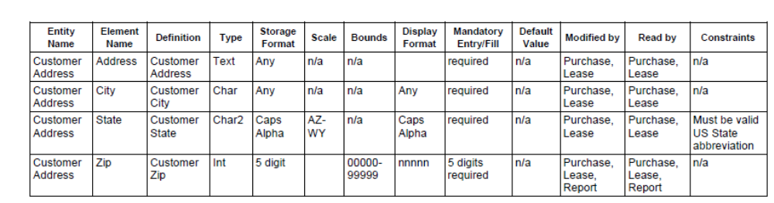
Note: Maintaining the Data Dictionary Table as a separate document and performing appropriate updates in a controlled fashion is more efficient than including it within the SDD and requiring that the SDD be revised each time the Data Dictionary Table is modified.

4 Functional Design
4.1 Describe the functionalities of the system:
This should include the diagrams that describe the functionalities of the software system. (Data Flow Diagram and description / Use case diagram, use case and actor description)
4.2 Behavioral design:
Behavioral diagrams (activity and state chart diagrams)
Interaction diagrams (sequence diagram)
5 Data Design
5.1 Global Data Structures:
Describe any data structures that are a major part of this system. This should include major data structures that are passed between components. That is, it is not restricted to truly global data structures.
5.2 Functional:
List all functions and function parameters.
For functions, give function input and output names in the description. Provide the decomposition diagrams. (Class diagram, component diagram / structural decomposition diagrams)
5.3 Logical data model or Entity relationship diagram(s):
Describe and provide an illustration of the logical data model or entity relationship diagram(s) for the Persistent/Static Data Store.
An example of a database logical model is included below.

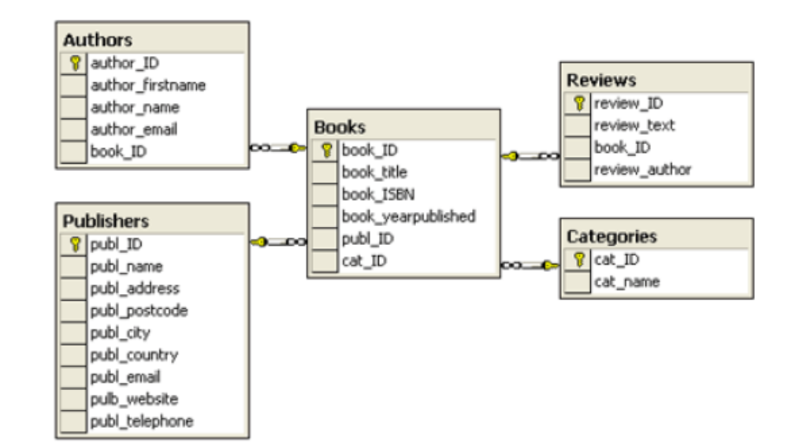
5.4 Database Description:
Describe the database(s) which is/are part of the system.

6 Human Interface Design
6.1 Overview of the User Interface
Provide a high-level description of the user interface for this software application. Describe any systems requirements (e.g., performance or usability) associated with all of the user interfaces.
6.2 Screen/Report Format/Other User Interface
Provide a description, and if appropriate, an image or mockup of each screen, report, or other user interface within this function or use case. For reports that use standard reporting tools (e.g., Crystal Reports) or standard data exchange languages (e.g., XML), describe the form and formatting for Report that uses these technologies.
7 Other Interfaces
Customize the following subsections to accurately and comprehensively document the design of any additional interfaces not described in the previous sections, including specific application-to-application interfaces, database-to-database interfaces, or other interfaces. In addition, identify the technology that will be used to enable the interaction. Label each subsection appropriately and title each subsection descriptively to indicate the interface being documented.
7.1 Interface 1
Describe the interface design including technology (e.g., XML), the protocol (e.g., TCP), any specific message formats, error conditions, handshakes, initiation and closure, and other features that define the design of the interface.

8 Other Design Features
Describe any design features that are not captured in the previous sections.

